LAB08 – Logic Analyzer (Simulator)
In this LAB we will make a shore assembler program that will use two variables ‘output’ and ‘increment’ to show the following signals in Logic Analyzer window:
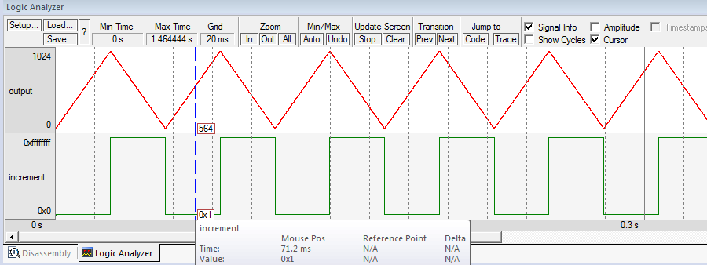

The algorithm is shown in the image below.
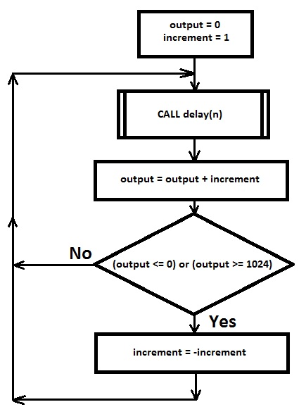
The same algorithm in the Python programming language:
output = 0
increment = 1
while True:
delay(50)
output = output + increment
if output <= 0 or output >= 1024:
increment = -increment

‘dealay’ is your delay function you made in Lab06. The parameter 50 will be quite good for simulator.
Let's start the project!
1. Create the directory named 'Lab08'. Download, unzip and copy file 'Template_Lab08.s' into your 'Lab07' directory. Rename 'Template_Lab08.s' to 'JoeTheStudent_Lab08.s' where 'JoeTheStudent' is your name or canvas login. Open 'Keil uVision' and create new project 'Lab08' like you did it for Lab05. Use usual project's settings.
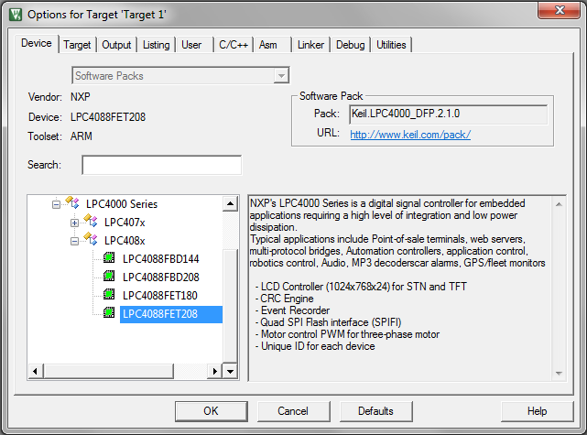
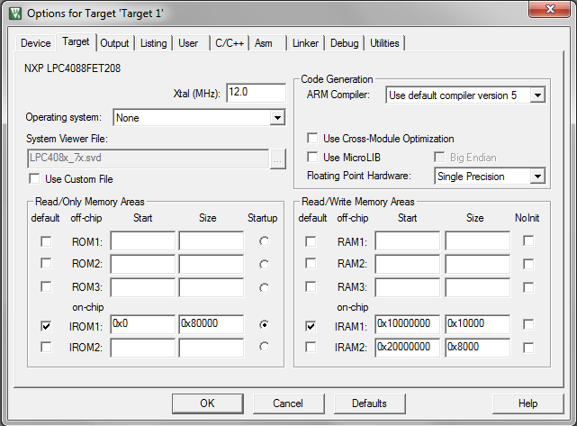
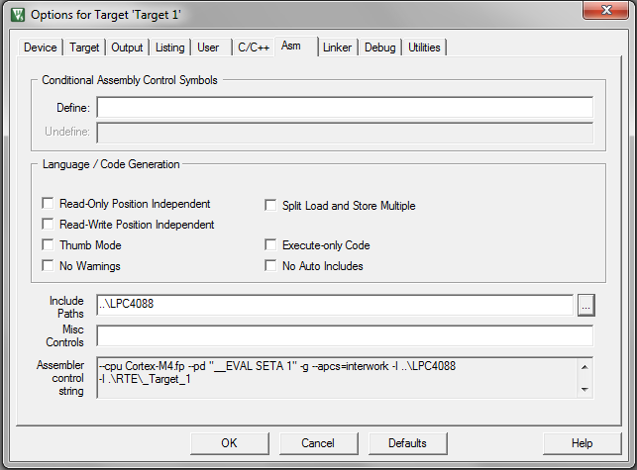
On ‘Asm’ tab, go to ‘Include Paths’ edit box and type ‘..\LPC4088’. It is important!
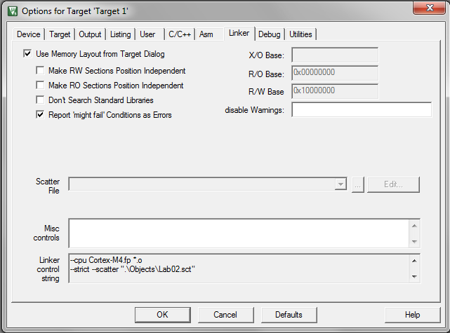
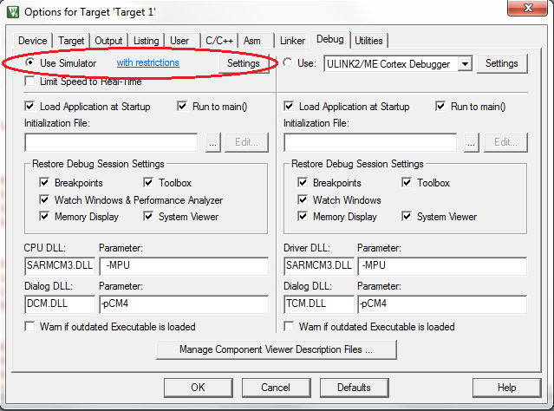
Important! We will use ‘Simulator’ for this Lab!
2. Add 'JoeTheStudent_Lab08.s' and 'LPC4088\startup_LPC407x_8x_177x_8x.s' files into your project. In ‘Add File’ dialog you will need to navigate to ‘..\LPC4088’ directory. Use standard ‘Up One Level’ button. Open 'JoeTheStudent_Lab08.s' file.
3. Locate ‘Step #1’ in the file.
;
; Step #1 - Define two variables: 'output' and 'increment'
;

Define two variables ‘output’ and ‘increment’ here. Variables may be 32-bit (word) or 16-bit (half-word). The ‘increment’ variable must be ‘signed’, because it will toggle between 1 and -1. The ‘output’ may be either ‘signed’ or ‘unsigned’.
Use slide #4 in Lecture presentation as an example and guideline.
4. Locate ‘Step #2’ in the file.
;
; Step #2 - Copy your 'delay' function from Lab06
;

Copy here your ‘delay’ function from your ‘Lab06’ project
5. Locate ‘Step #3’ in the file.
;
; Step #3 - Write your program in assembler. An approximate algorithm in Python:
;
; output = 0
; increment = 1
; while True:
; delay(50)
; output = output + increment
; if output <= 0 or output >= 1024:
; increment = -increment
;
; The graphical algorithm is given in the 'Lab08.doc' document.
;

5.A. Use the code example in lecture presentation as general guidelines.
5.B. Spend some time for planning and assign registers to some variables and constants you may need.
5.C. ‘output’ and ‘increment’ are variables in data memory. To access to variables, use the same technique as in Lecture presentation – ‘Base and offset’ method. Use some CPU register as base address.
5.D. Use ‘main_delay’, ‘out_min’ and ‘out_max’ definitions instead of 50, 0 and 1024 constants. The EQU definitions are done in the template file for you. (On the top of the file, between ‘ENTRY’ and ‘SysInit’). Since ‘out_min’ and ‘out_max’ may be ‘bad constants’, it is better to do something like:
LDR R1, =out_max
CMP R4, R1

Instead of:
CMP R4, #out_max
5.E. Do not use ‘ORR’ command in ‘output <= 0 or output >= 1024’ expression! In assembler it will be simpler to do like this:
if output <= 0: increment = -increment
if output >= 1024: increment = -increment

Remember: almost all instructions in ARM processor may be ‘conditional’.

6. Locate ‘Step #4’ in the file.
;
; Step #4 - Define variables 'output' and 'increment' as global.
;

You may use ‘EXPORT’ or ‘GLOBAL’ assembler directives.
See slide #10 in Lecture presentation as an example and guideline.
7. Compile your project; make sure you have no assembler errors. Start the simulator. Then setup the Logic Analyzer to show ‘output’ and ‘increment’ variables. See slides ##11-15 for guidelines.
7.A. Your settings for variables should be like this:
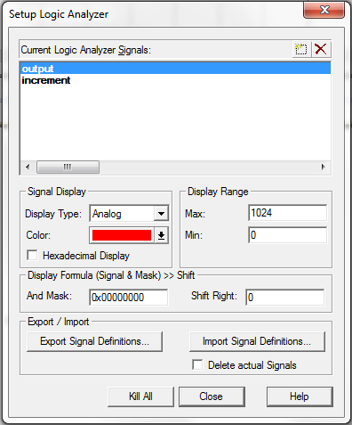
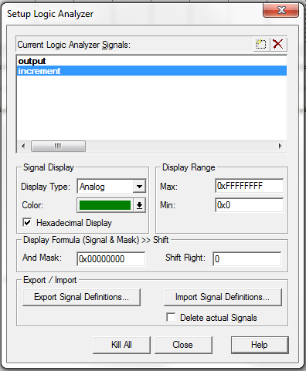
8. Run the simulator; make sure you have a correct picture. See slides ##16-19 of Lecture Presentation.
8.A. Please note, the on the Analyzer’s window, the ‘increment’ variable changes between 1 and 0xFFFFFFF, not between 1 and -1. It is because the Analyzer can show ‘unsigned’ numbers only. As you already know, the two’s complement ‘-1’ is 0xFFFFFFFF.
9. Ask your questions by e-mail! You will be answered promptly!
10. Zip and submit 'JoeTheStudent_Lab08.s' file when done.

